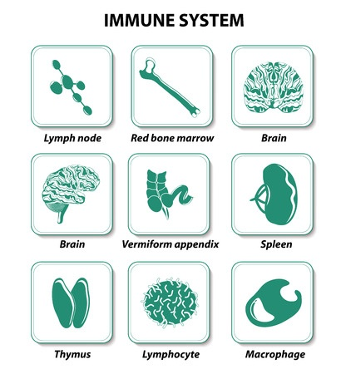
Self-Healing Auto-Immunity (AI)

Paula Youmell, RN

2-Hour Workshop:
Tuesday, October 18, 5:30-7:30 PM

“All disease begins in the gut”
–Hippocrates, Greek Physician nearly 2500 years ago

Workshop Description, Lecture and Q&A:
- Root causes of AI to support you working cooperatively with your primary care
- Gut health and how it contributes to auto-immunity
- What creates gut health, maintains it, and steps to heal when it’s distressed
- What contributes to food sensitivities and immune system overload
- Dietary habits to heal the gut, decrease inflammation, & contribute to self-healing

Relax into an acupuncture treatment to soothe inflammation and calm your immune system
Be prepared to take notes for post class reference and Q&A.
Workshop Tuition: $65

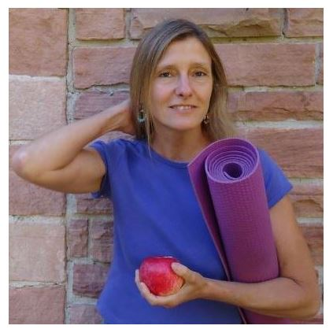
Paula Youmell, RN, Wise Woman Nurse®

I am a NYS Licensed RN and Health & Physical Education teacher trained in Functional Medicine, Herbalism, Yoga, & Energy Medicine with 37 years of experience in Natural Health.

www.PaulaYoumellRN.com

