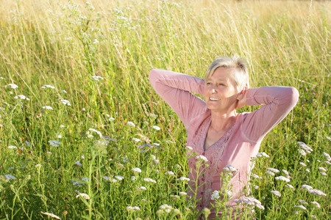
Menopausal Health
for
Vitality Workshop

Paula Youmell, RN
2-Hour Workshop:
Date: Tuesday, November 8th
Time: 5:30-7:30 PM

"At menarche a woman enters her power,
Throughout her menstruating years she practices her power,
At menopause she becomes her power."
Native American Saying

Workshop Description, Lecture and Q&A on self-care tools to navigate peri-menopause and menopausal years with ease, health, and vitality”
- Hormonal Health & Herbs to support
- Whole food nourishment for healthy weight, balanced hormones, & supporting your whole body’s menopausal health
- Mood & energy concerns
- Maintaining healthy muscles and bones in our vibrant years
Relax into an acupuncture treatment, during Q&A, to balance your body’s health.
Be prepared to take notes for post class reference and Q&A.
Workshop Tuition: $65
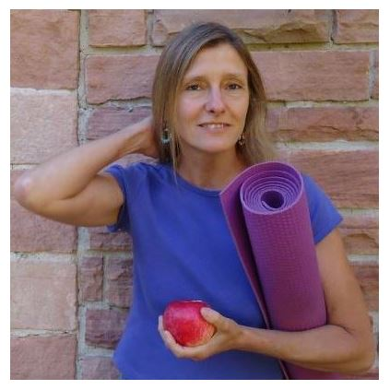

Paula Youmell, RN, Wise Woman Nurse®
I am a NYS Licensed RN and Health & Physical Education teacher trained in Functional Medicine, Herbalism, Yoga, & Energy Medicine with 37 years of experience in Natural Health.

www.PaulaYoumellRN.com

